Source Code:
`timescale 1ns/1ps

module fifo (
input clk,
input rst,
input wren,
input rden,
input [7:0] din,

output reg [7:0] dout,
output full,
output empty
);

parameter DEPTH = 16;
parameter ADDR_WIDTH = 4;

//(* ram_style = "block" *)
//(* ram_style = "distributed" *)

reg [7:0] mem [0:DEPTH-1];

reg [ADDR_WIDTH-1:0] wr_ptr;
reg [ADDR_WIDTH-1:0] rd_ptr;
reg [4:0] count;

assign full = (count == DEPTH);
assign empty = (count == 0);

always @(posedge clk or posedge rst)
begin
if(rst)
begin
wr_ptr <= 0;
rd_ptr <= 0;
count <= 0;
dout <= 0;
end
else
begin
// Write only
if(wren && !full && !(rden && !empty))
begin
mem[wr_ptr] <= din;
wr_ptr <= wr_ptr + 1;
count <= count + 1;
end

// Read only
else if(rden && !empty && !(wren && !full))
begin
dout <= mem[rd_ptr];
rd_ptr <= rd_ptr + 1;
count <= count - 1;
end

// Read and Write together
else if(wren && !full && rden && !empty)
begin
mem[wr_ptr] <= din;
dout <= mem[rd_ptr];
wr_ptr <= wr_ptr + 1;
rd_ptr <= rd_ptr + 1;
count <= count;
end
end
end

endmodule

Test Bench:
module fifo_tb;

reg clk;
reg rst;
reg wren;
reg rden;
reg [7:0] din;

wire [7:0] dout;
wire full;
wire empty;

fifo uut(
.clk(clk),
.rst(rst),
.wren(wren),
.rden(rden),
.din(din),
.dout(dout),
.full(full),
.empty(empty)
);

// Clock Generation
always #5 clk = ~clk;

// Test Sequence
initial
begin

clk = 0;
rst = 1;
wren = 0;
rden = 0;
din = 0;

#20;
rst = 0;

// WRITE TEST
wren = 1;

din = 8'h11; #10;
din = 8'h22; #10;
din = 8'h33; #10;
din = 8'h44; #10;
din = 8'h55; #10;

wren = 0;

#20;
// READ TEST
rden = 1;

#10;
#10;
#10;
#10;
#10;

rden = 0;

#20;
// OVERFLOW TEST
wren = 1;

repeat(18)
begin
din = din + 1;
#10;
end

wren = 0;

#20;
// UNDERFLOW TEST
rden = 1;

repeat(18)
#10;

rden = 0;

#30;

$finish;

end

initial
begin
$monitor("Time=%0t WR=%b RD=%b DIN=%h DOUT=%h COUNT=%0d FULL=%b EMPTY=%b",
$time,wren,rden,din,dout,uut.count,full,empty);
end

// Waveform Dump
initial
begin
$dumpfile("fifo.vcd");
$dumpvars(0,fifo_tb);
end

endmodule
Output:
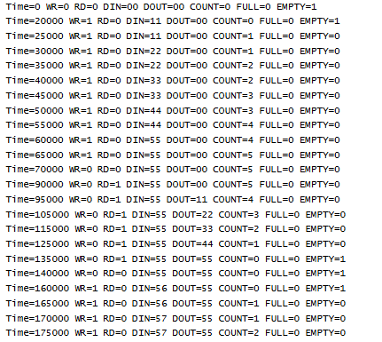
Waveform:
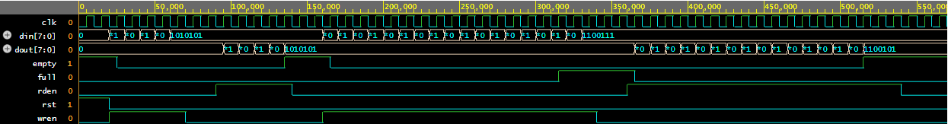

ModelSim:
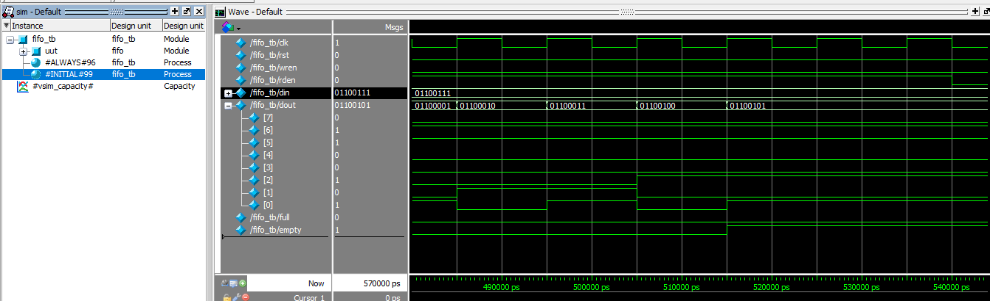
Source Code:
module sequential_multiplier(
input clk,
input reset,
input start,
input [3:0] multiplicand,
input [3:0] multiplier,
output [7:0] product,
output done
);

wire w_LoadM, w_LoadQ, w_ClearA, w_Add, w_ShiftAQ, w_Count;
wire w_q0, w_count_done;

// Instantiate Controller
controller ctrl (
.clk(clk), .reset(reset), .start(start),
.q0(w_q0), .count_done(w_count_done),
.LoadM(w_LoadM), .LoadQ(w_LoadQ), .ClearA(w_ClearA),
.Add(w_Add), .ShiftAQ(w_ShiftAQ), .Count(w_Count),
.Done(done)
);

// Instantiate Datapath
datapath dp (
.clk(clk), .reset(reset),
.multiplicand_in(multiplicand), .multiplier_in(multiplier),
.LoadM(w_LoadM), .LoadQ(w_LoadQ), .ClearA(w_ClearA),
.Add(w_Add), .ShiftAQ(w_ShiftAQ), .Count(w_Count),
.q0(w_q0), .count_done(w_count_done),
.product(product)
);

endmodule

module datapath(
input clk,
input reset,
input [3:0] multiplicand_in,
input [3:0] multiplier_in,
input LoadM,
input LoadQ,
input ClearA,
input Add,
input ShiftAQ,
input Count,
output q0,
output count_done,
output [7:0] product
);

reg [3:0] M;
reg [3:0] A;
reg [3:0] Q;
reg C;
reg [2:0] counter;

// Parallel Adder Logic
wire [4:0] adder_out = A + M;

always @(posedge clk or posedge reset) begin
if (reset) begin
M <= 4'b0;
A <= 4'b0;
Q <= 4'b0;
C <= 1'b0;
counter <= 3'b0;
end else begin

if (LoadM)
M <= multiplicand_in;

if (ClearA) begin
A <= 4'b0;
C <= 1'b0;
end

// Load Multiplier
if (LoadQ)
Q <= multiplier_in;

if (Add) begin
{C, A} <= adder_out;
end

if (ShiftAQ) begin
// Logical right shift: 0 -> C -> A -> Q
{C, A, Q} <= {1'b0, C, A, Q[3:1]};
end

// Counter Logic
if (ClearA)
counter <= 3'b0;
else if (Count)
counter <= counter + 1'b1;
end
end

// Status signals for Controller
assign q0 = Q[0];
assign count_done = (counter == 4);
assign product = {A, Q};

endmodule

module controller(
input clk,
input reset,
input start,
input q0,
input count_done,
// Control signal outputs
output reg LoadM,
output reg LoadQ,
output reg ClearA,
output reg Add,
output reg ShiftAQ,
output reg Count,
output reg Done
);

typedef enum reg [2:0] {
S_IDLE = 3'b000,
S_START = 3'b001,
S_CHECK = 3'b010,
S_ADD = 3'b011,
S_SHIFT = 3'b100,
S_DONE = 3'b101
} state_t;

state_t current_state, next_state;

// State Transition
always @(posedge clk or posedge reset) begin
if (reset) current_state <= S_IDLE;
else current_state <= next_state;
end

always @(*) begin

LoadM = 0; LoadQ = 0; ClearA = 0; Add = 0;
ShiftAQ = 0; Count = 0; Done = 0;
next_state = current_state;

case (current_state)
S_IDLE: begin
if (start) next_state = S_START;
end

S_START: begin
LoadM = 1;
LoadQ = 1;
ClearA = 1;
next_state = S_CHECK;
end

S_CHECK: begin
if (count_done)
next_state = S_DONE;
else if (q0)
next_state = S_ADD;
else
next_state = S_SHIFT;
end

S_ADD: begin
Add = 1;
next_state = S_SHIFT;
end

S_SHIFT: begin
ShiftAQ = 1;
Count = 1;
next_state = S_CHECK;
end

S_DONE: begin
Done = 1;
if (!start) next_state = S_IDLE;
end
endcase
end
endmodule

Test Bench:
module tb_multiplier();
reg clk, reset, start;
reg [3:0] m, q;
wire [7:0] p;
wire done;

sequential_multiplier uut (clk, reset, start, m, q, p, done);

always #5 clk = ~clk;

initial begin
$dumpfile("dump.vcd"); $dumpvars;
clk = 0; reset = 1; start = 0;
m = 4'd10; q = 4'd3; // 10 * 3 = 30 (8'b00011110)
#15 reset = 0;
#10 start = 1;
#10 start = 0;

wait(done);
$display("Result: %d * %d = %d", m, q, p);

#20;
m = 4'd7; q = 4'd5; // 7 * 5 = 35 (8'b00100011)
start = 1;
#10 start = 0;

wait(done);
$display("Result: %d * %d = %d", m, q, p);
#50 $finish;
end
endmodule

Waveform:

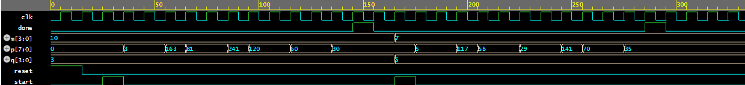
Source Code:
`timescale 1ns/1ps

module lab3_fsm (
input [1:0] SW, // SW[0] is synchronous reset_n, SW[1] is w
input [0:0] KEY, // KEY[0] is manual clock
output [9:0] LEDR // LEDR[8:0] is y8-y0, LEDR[9] is z
);
wire w, reset_n, clk;
assign w = SW[1];
assign reset_n = SW[0];
assign clk = KEY[0];

wire [8:0] y; // Outputs of flip-flops
wire [8:0] Y; // Logic feeding flip-flops

// --- Logic Expressions (Derived by Inspection for Modified One-Hot) ---

// According to Step 6: State A is when y0 = 0.
// Therefore, we are in State A if ~y0 is true.
wire state_A = ~y[0];

// Y0 logic: y0 should be 1 if we are in ANY state other than A.
// So if we are in A and get a signal, or if we are already in B-I.
assign Y[0] = 1'b1;

// To State B (y1): If w=0 and (State A OR State F,G,H,I)
assign Y[1] = ~w & (state_A | y[5] | y[6] | y[7] | y[8]);

// To State C (y2): If w=0 and in B
assign Y[2] = ~w & y[1];

// To State D (y3): If w=0 and in C
assign Y[3] = ~w & y[2];

// To State E (y4): If w=0 and in (D or E)
assign Y[4] = ~w & (y[3] | y[4]);

// To State F (y5): If w=1 and (State A OR State B,C,D,E)
assign Y[5] = w & (state_A | y[1] | y[2] | y[3] | y[4]);

// To State G (y6): If w=1 and in F
assign Y[6] = w & y[5];

// To State H (y7): If w=1 and in G
assign Y[7] = w & y[6];

// To State I (y8): If w=1 and in (H or I)
assign Y[8] = w & (y[7] | y[8]);

// --- Instantiate Flip-Flops ---
// Step 2 Requirement: Instantiate nine flip-flops.
// Step 6 Requirement: All flip-flop outputs reset to 0.
genvar i;
generate
for (i = 0; i <= 8; i = i + 1) begin : ffs
d_ff_sync flip_flop (
.d(Y[i]),
.clk(clk),
.reset_n(reset_n),
.q(y[i])
);
end
endgenerate

// --- Output Logic ---
assign LEDR[8:0] = y;
assign LEDR[9] = y[4] | y[8]; // z = 1 if in state E or I

endmodule

// D-Flip-Flop with Synchronous Reset (as per Lab Step 2)
module d_ff_sync (
input d,
input clk,
input reset_n,
output reg q
);
always @(posedge clk) begin
if (!reset_n)
q <= 1'b0;
else
q <= d;
end
endmodule

Test Bench:
`timescale 1ns/1ps

module tb_lab3_fsm();
reg [1:0] SW;
reg [0:0] KEY;
wire [9:0] LEDR;

lab3_fsm uut (.SW(SW), .KEY(KEY), .LEDR(LEDR));

// Manual Clock Task
task tick;
begin
#10 KEY[0] = 1; #10 KEY[0] = 0; #10;
end
endtask

initial begin
$dumpfile("dump.vcd"); $dumpvars;
// Setup initial values
KEY[0] = 0; SW = 2'b00; // Reset active, w=0

// 1. Test Synchronous Reset
tick; // Reset happens on rising edge
$display("State after Reset: %b (Should be all 0s)", LEDR[8:0]);

// 2. Release Reset and apply four 1s
SW[0] = 1; SW[1] = 1; // w = 1
tick; // To State F
tick; // To State G
tick; // To State H
tick; // To State I
$display("State after 1111: %b, z: %b", LEDR[8:0], LEDR[9]);

// 3. Test Overlapping 1
tick; // Stay in State I
$display("State after 11111: %b, z: %b (z should be 1)", LEDR[8:0], LEDR[9]);

// 4. Transition to 0s
SW[1] = 0; // w = 0
tick; // To State B
tick; // To State C
tick; // To State D
tick; // To State E
$display("State after 0000: %b, z: %b", LEDR[8:0], LEDR[9]);

#20 $finish;
end
endmodule
Output:
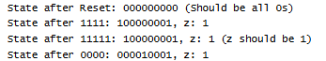
Waveform:

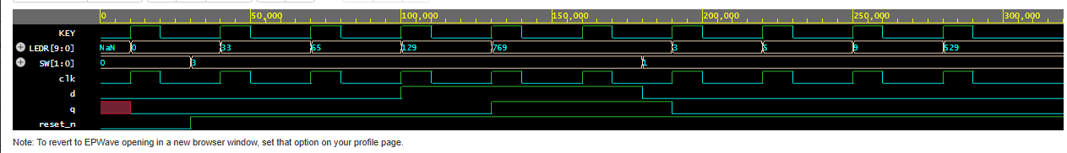
Source Code:
Test Bench:
Output:
Waveform:

Source Code:
`timescale 1ns / 1ps

module VGA_top (
input wire clk_50,
input wire reset_btn, // Assume active low
output wire vga_hsync, vga_vsync,
output wire [7:0] vga_r, vga_g, vga_b,
output wire [19:0] SRAM_ADDR,
inout wire [15:0] SRAM_DQ,
output wire SRAM_CE_N, SRAM_OE_N, SRAM_WE_N,
output wire [6:0] hex0, hex1,
output wire led_blink, led_lock
);

wire clk_65, locked, reset_n;
wire [10:0] x, y;
wire video_on;
wire [7:0] color;

// --- PLL / Clock Generation ---
// In EDA Playground, we simulate a 65MHz clock directly.
// On hardware, you would replace this with an Altera/Xilinx PLL IP.
reg clk_65_reg = 0;
reg lock_reg = 0;
always #7.7 clk_65_reg = ~clk_65_reg; // 7.7ns toggle = ~65MHz
initial #100 lock_reg = 1; // Mock PLL locking

assign clk_65 = clk_65_reg;
assign led_lock = lock_reg;
assign reset_n = reset_btn & lock_reg;

// --- 7-Segment Display (Group 12) ---
// Patterns for common cathode (0 = off, 1 = on)
assign hex1 = 7'b0000110; // "1"
assign hex0 = 7'b1011011; // "2"

// --- Blinking LED (1 second) ---
reg [25:0] blink_cnt;
reg blink_reg;

// ADJUST FOR SIMULATION:
// Hardware needs 32,500,000 for 0.5s toggle.
// Simulation needs a small number to avoid timeout.
parameter BLINK_LIMIT = 26'd1000;

always @(posedge clk_65 or negedge reset_n) begin
if (!reset_n) begin
blink_cnt <= 0;
blink_reg <= 0;
end else begin
if (blink_cnt >= BLINK_LIMIT) begin
blink_cnt <= 0;
blink_reg <= ~blink_reg;
end else begin
blink_cnt <= blink_cnt + 1;
end
end
end
assign led_blink = blink_reg;

// --- VGA Controller (Hierarchy Part 1) ---
vga_controller sync_gen (
.clk_65(clk_65),
.reset_n(reset_n),
.hsync(vga_hsync),
.vsync(vga_vsync),
.video_on(video_on),
.pixel_x(x),
.pixel_y(y)
);

// --- Memory Interface (Hierarchy Part 2) ---
memory_interface mem_ctrl (
.clk_65(clk_65),
.px(x),
.py(y),
.video_on(video_on),
.sram_addr(SRAM_ADDR),
.sram_dq(SRAM_DQ),
.sram_ce_n(SRAM_CE_N),
.sram_oe_n(SRAM_OE_N),
.sram_we_n(SRAM_WE_N),
.pixel_data(color)
);

// Output colors (Grayscale mapping)
assign vga_r = color;
assign vga_g = color;
assign vga_b = color;

endmodule

// --- Sub-Module: VGA Sync Generator ---
module vga_controller (
input wire clk_65, reset_n,
output reg hsync, vsync, video_on,
output wire [10:0] pixel_x, pixel_y
);
// 1024x768 @ 60Hz timing
parameter H_ACTIVE = 1024, H_FP = 24, H_SYNC = 136, H_BP = 160, H_TOTAL = 1344;
parameter V_ACTIVE = 768, V_FP = 3, V_SYNC = 6, V_BP = 29, V_TOTAL = 806;

reg [10:0] h_cnt, v_cnt;

always @(posedge clk_65 or negedge reset_n) begin
if (!reset_n) begin
h_cnt <= 0; v_cnt <= 0;
end else begin
if (h_cnt == H_TOTAL - 1) begin
h_cnt <= 0;
if (v_cnt == V_TOTAL - 1) v_cnt <= 0;
else v_cnt <= v_cnt + 1;
end else h_cnt <= h_cnt + 1;
end
end

always @(posedge clk_65) begin
hsync <= ~((h_cnt >= (H_ACTIVE + H_FP)) && (h_cnt < (H_ACTIVE + H_FP + H_SYNC)));
vsync <= ~((v_cnt >= (V_ACTIVE + V_FP)) && (v_cnt < (V_ACTIVE + V_FP + V_SYNC)));
video_on <= (h_cnt < H_ACTIVE) && (v_cnt < V_ACTIVE);
end

assign pixel_x = h_cnt;
assign pixel_y = v_cnt;
endmodule

// --- Sub-Module: SRAM Memory Interface ---
module memory_interface (
input wire clk_65,
input wire [10:0] px, py,
input wire video_on,
output wire [19:0] sram_addr,
inout wire [15:0] sram_dq,
output wire sram_ce_n, sram_oe_n, sram_we_n,
output reg [7:0] pixel_data
);
// Address = Row * 1024 + Col
assign sram_addr = {py[9:0], px[9:0]};
assign sram_ce_n = 1'b0; // Always selected
assign sram_oe_n = 1'b0; // Always output enabled
assign sram_we_n = 1'b1; // Write disabled (Read Only)

always @(posedge clk_65) begin
// If within screen boundaries, read from SRAM data bus
pixel_data <= (video_on) ? sram_dq[7:0] : 8'h00;
end
endmodule
Test Bench:
`timescale 1ns / 1ps

module VGA_top_tb();
reg clk_50;
reg reset_btn;
wire vga_hsync, vga_vsync;
wire [7:0] vga_r, vga_g, vga_b;
wire [19:0] SRAM_ADDR;
wire [15:0] SRAM_DQ;
wire SRAM_CE_N, SRAM_OE_N, SRAM_WE_N;
wire led_blink, led_lock;

// Instantiate UUT
VGA_top uut (
.clk_50(clk_50), .reset_btn(reset_btn),
.vga_hsync(vga_hsync), .vga_vsync(vga_vsync),
.vga_r(vga_r), .vga_g(vga_g), .vga_b(vga_b),
.SRAM_ADDR(SRAM_ADDR), .SRAM_DQ(SRAM_DQ),
.SRAM_CE_N(SRAM_CE_N), .SRAM_OE_N(SRAM_OE_N), .SRAM_WE_N(SRAM_WE_N),
.led_blink(led_blink), .led_lock(led_lock),
.hex0(), .hex1()
);

// Mock SRAM Behavioral Model
// Put the low 8 bits of the address on the data bus so we can see it change
assign SRAM_DQ = (!SRAM_OE_N) ? {8'h00, SRAM_ADDR[7:0]} : 16'hZZZZ;

// Generate 50MHz Clock
initial clk_50 = 0;
always #10 clk_50 = ~clk_50;

initial begin
// For EDA Playground: This creates the wave file
$dumpfile("dump.vcd");
$dumpvars(0, VGA_top_tb);

$display("--- Starting VGA Simulation ---");
reset_btn = 0; // Reset active
#150;
reset_btn = 1; // Release reset

// Wait for Mock PLL to Lock
wait(led_lock == 1);
$display("Time: %t | PLL Locked", $time);

// Run simulation for exactly 2 lines of video to prevent timeout
// 1 line = 1344 clocks. 2 lines approx 2700 clocks.
repeat (2700) @(posedge clk_50);

$display("Time: %t | Simulation Finished Successfully", $time);
$finish;
end
endmodule
Output:
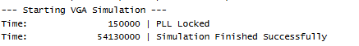
Waveform:
